LAPTOP PROGRAM

Dear Parent/Guardian,

At Wheelers Hill Secondary College (WHSC), we have a very successful laptop program and all students from Years 7-12 will be required to own a laptop to enhance their participation in the College’s educational program. We provide this information to families to assist them in purchasing the required designated computer devices for their students.

The College will continue to connect families with an educational provider, Learning with Technologies (LWT), who provide laptops, complete with the Department of Education and Training (DET) standard configuration including Windows 10, insurance, warranty and payment options.

A significant list of software is installed on each laptop and will be available to the student during their enrolment at our College. If students leave our school they will need to arrange with us to have this image removed and replaced with the Factory image as the DET/WHSC software will cease to function when a student exits our College.

Specifications and comparisons for the currently available models selected for students are listed on the following page. These three models have been carefully chosen and are the only ones currently designated for WHSC. These models may be updated as new ones becomes available from the manufacturer.

All advice regarding the laptop program is available on Compass under the Community tab in the ‘School Documentation’, ‘Year 7, 2019’ folder. As further advice becomes available, it will also be uploaded in this file on Compass.

To facilitate rollout in early 2019, we would like families to complete all orders on the LWT portal by Monday 7 December, 2018.

The LWT portal can be accessed at: http://wheelershillsc.orderportal.com.au

Regards,
Aaron Smith
COLLEGE PRINCIPAL

Laptop device cost comparison

Lenovo 11e Yoga 5th Gen i3 (128GB)
$1168.00 inc. GST

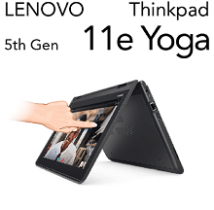
Price includes
CPU | Intel Core m3-7Y30 Processor 2.60 GHz
RAM | 4GB DDR3
Storage | 128GB Solid State Disk
Battery | Up to 12 hours with normal use
Weight | 1.6kg
Wireless | Intel Dual Band Wireless-AC 7265 802.11ac/a/b/g/n
Screen | 11.6" HD LED (1366 x 768) Touch Screen
Stylus | Active Stylus
Warranty | 3 year on-site
Insurance | Accidental Damage Cover, $100 excess

Lenovo Yoga L380 i5 (128GB)
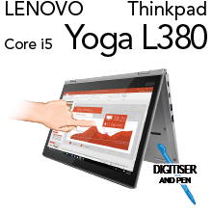
$1299.00 inc. GST

Price includes
CPU | Intel Core i5-8250U 3.40GHz
RAM | 4GB DDR3
Storage | 128GB Solid State Disk
Battery | Up to 12 hours with normal use
Weight | 1.37kg
Wireless | Intel Dual Band Wireless-AC 8265 (802.11ac)
Screen | 13.3” FHD (1920x1080) with Multi Touch
Stylus | Active Stylus
Warranty | 3 year on-site
Insurance | Accidental Damage Cover, $100 excess

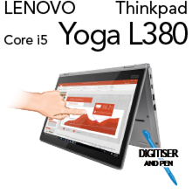
Lenovo Yoga L380 i5 (256GB)
$1422.00 inc. GST

Price includes
CPU | Intel Core i5-8250U 3.40GHz
RAM | 8GB DDR3
Storage | 256GB Solid State Disk
Battery | Up to 12 hours with normal use
Weight | 1.37kg
Wireless | Intel Dual Band Wireless-AC 8265 (802.11ac)
Screen | 13.3” FHD (1920x1080) with Multi Touch
Stylus | Active Stylus
Warranty | 3 year on-site
Insurance | Accidental Damage Cover, $100 excess

